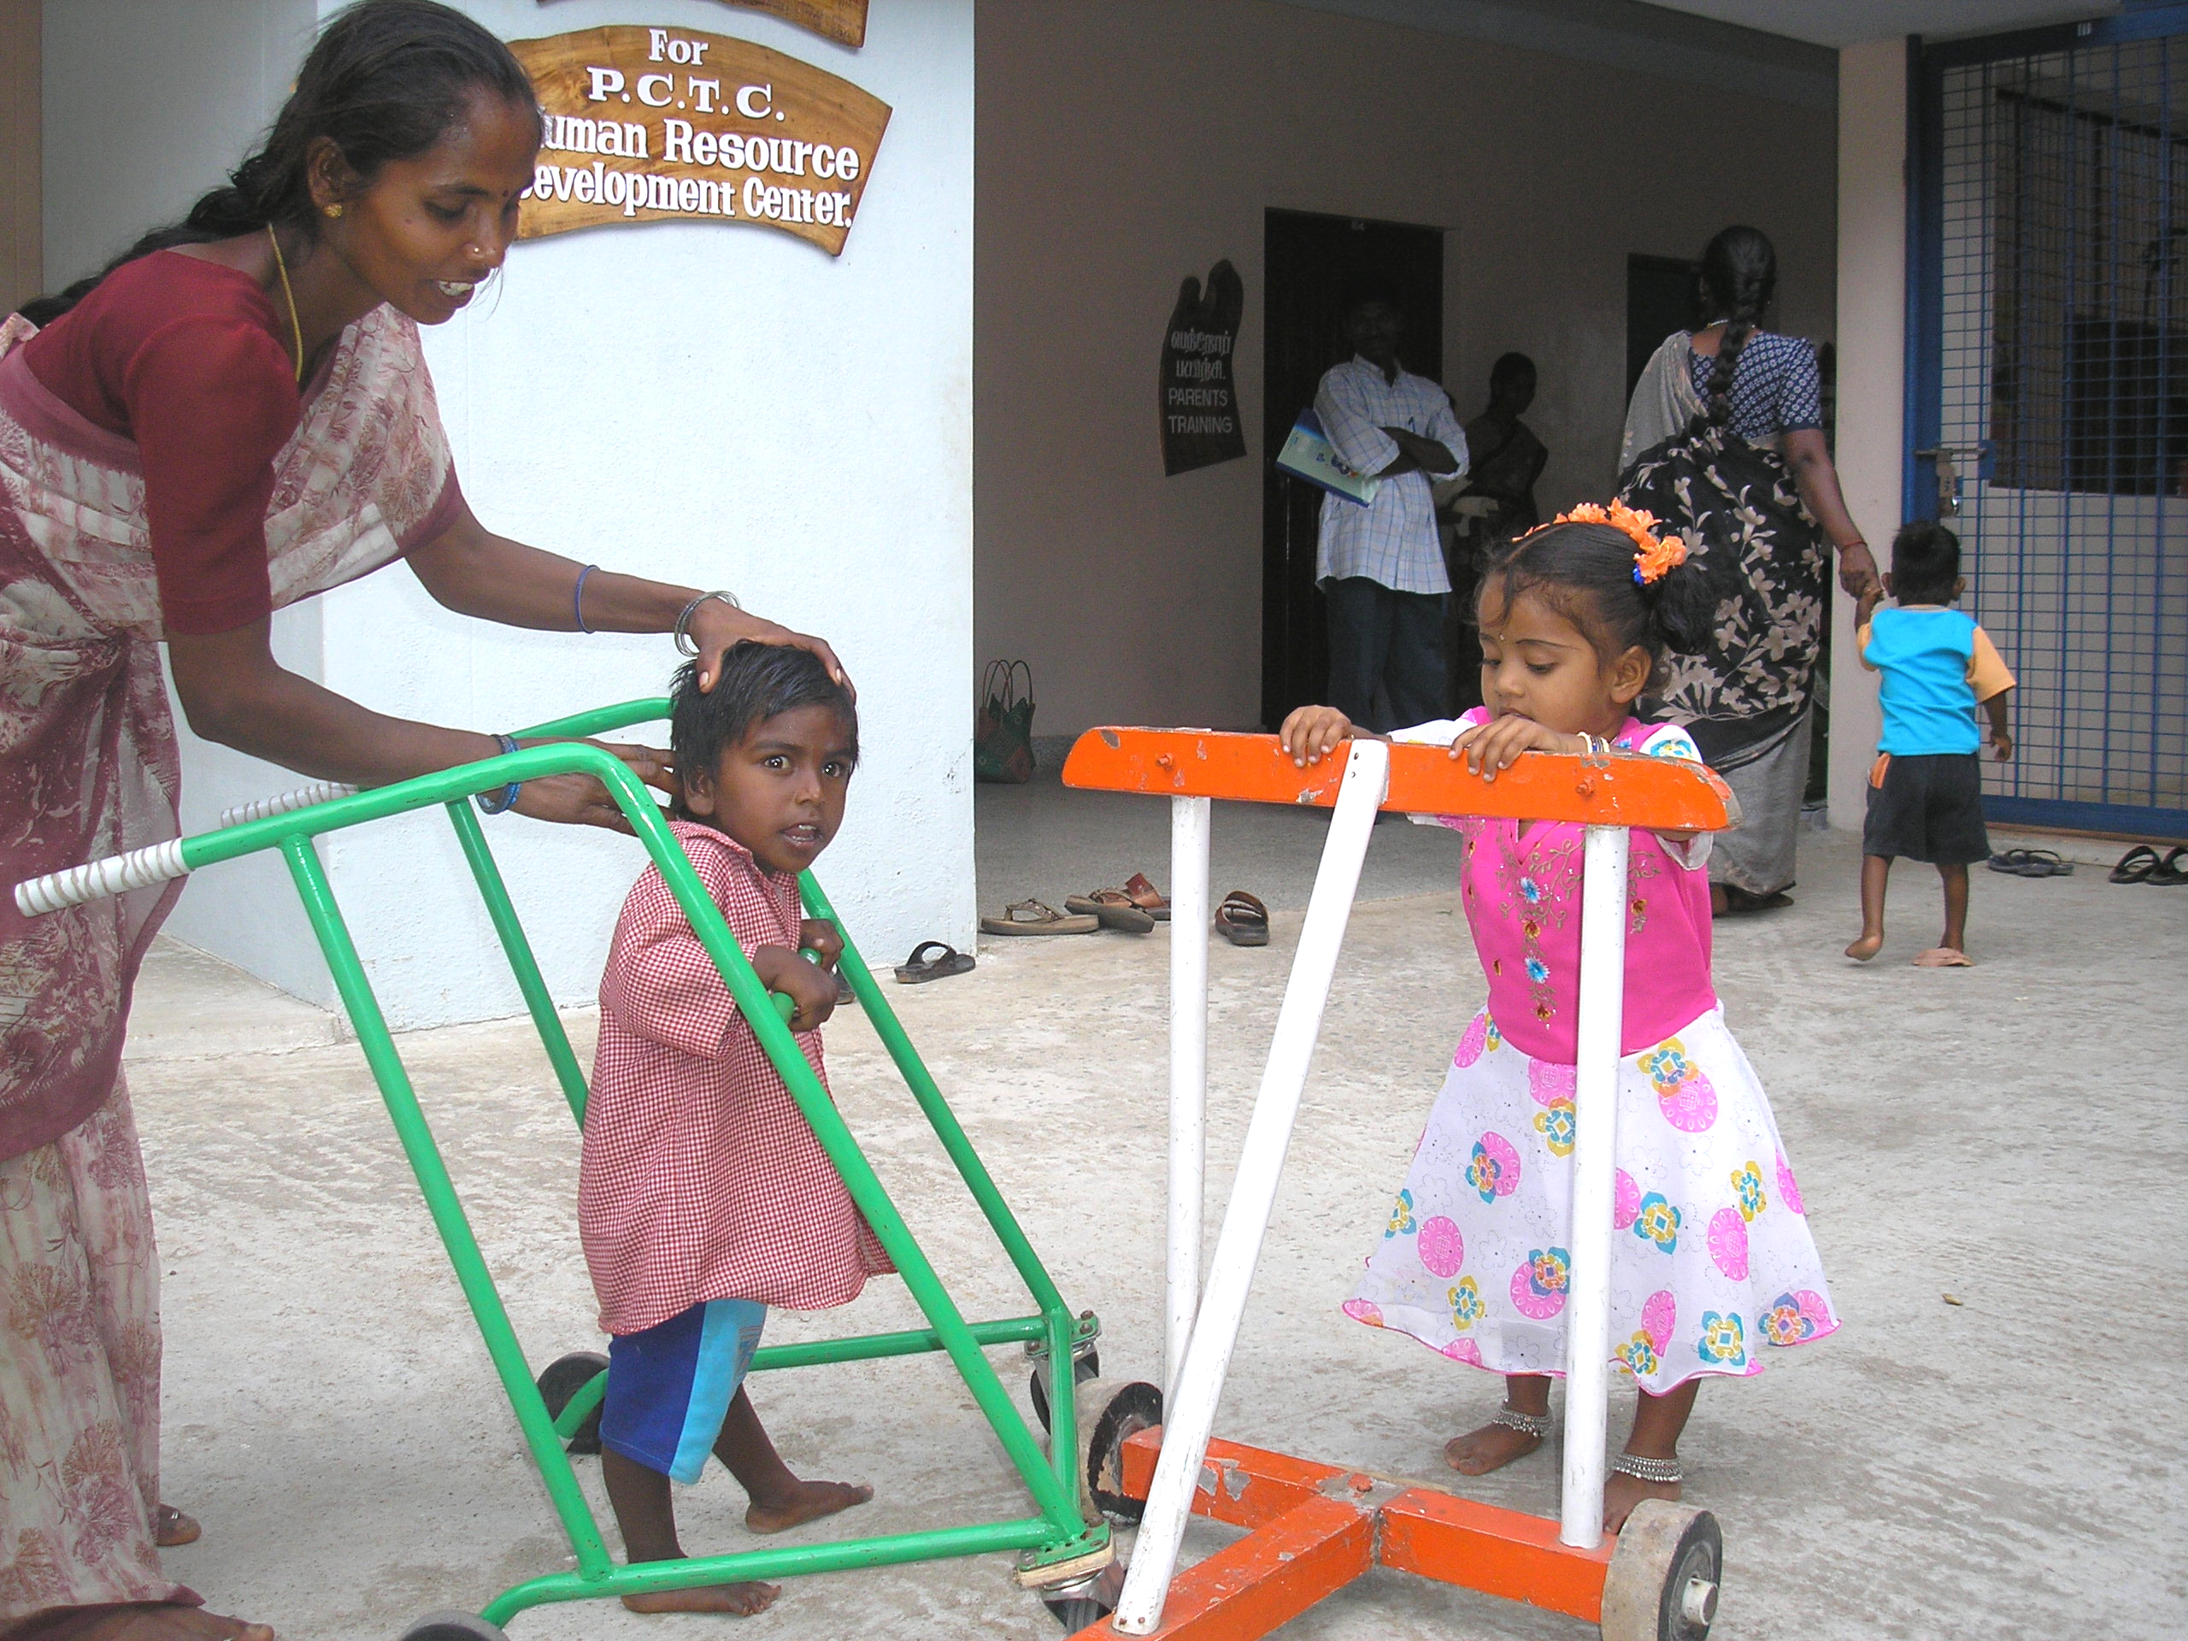
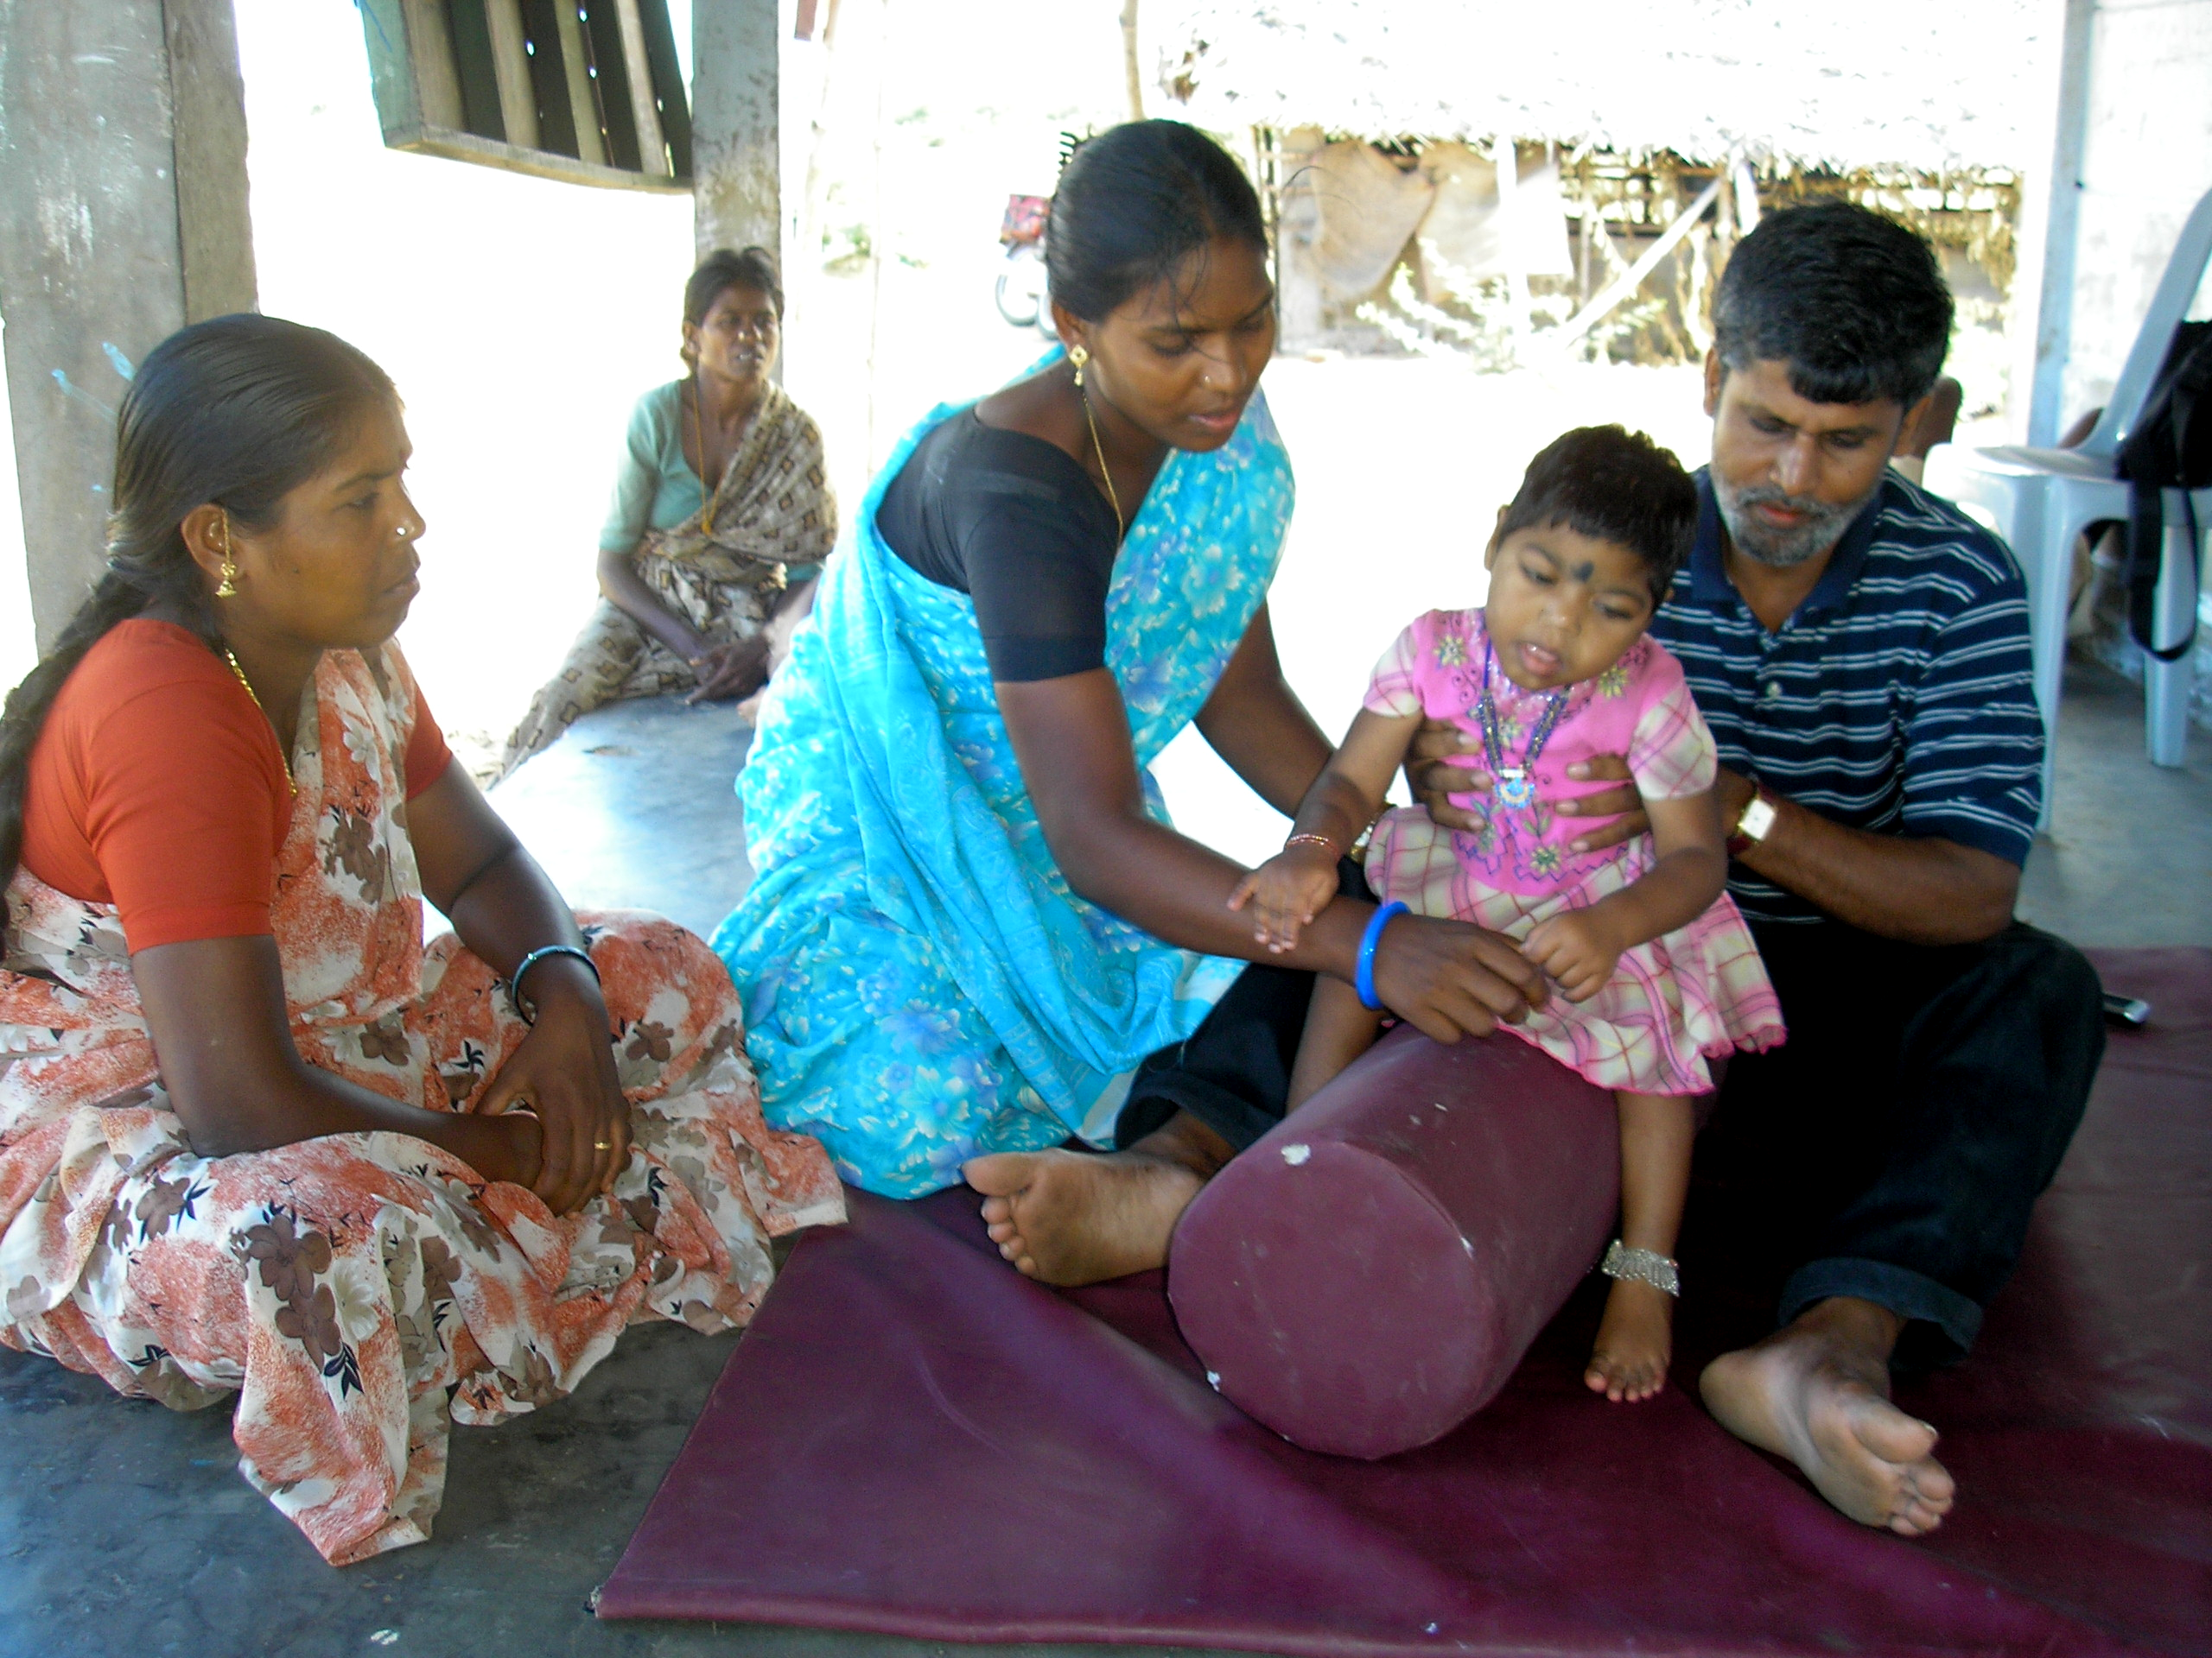

PEOPLE’S CRAFT TRAINING CENTER (PCTC)
KONDAM-KARIYANDAL, VIA-NAYUDUMANGALAM-606802,
TIRUVANNAMALAI DISTRICT.PH:04175-246464, FAX:04175-246215,
EMAIL:pctcxavi@sancharnet.in, Website: www.pctck.org

Community Based Rehabilitation Program:

Since our concentration is in one Block-Thurinchapuram, we were not only able to address the needs of the individuals but were able to have an integrated approach in family development activities too.

120 children were regular with their parents for the parents training program. During the parent training program we were able to initiate group activities to inculcate more involvement of the parents. Thanks to technical support of Vidya sagar Chennai during their bi monthly visits to PCTC.

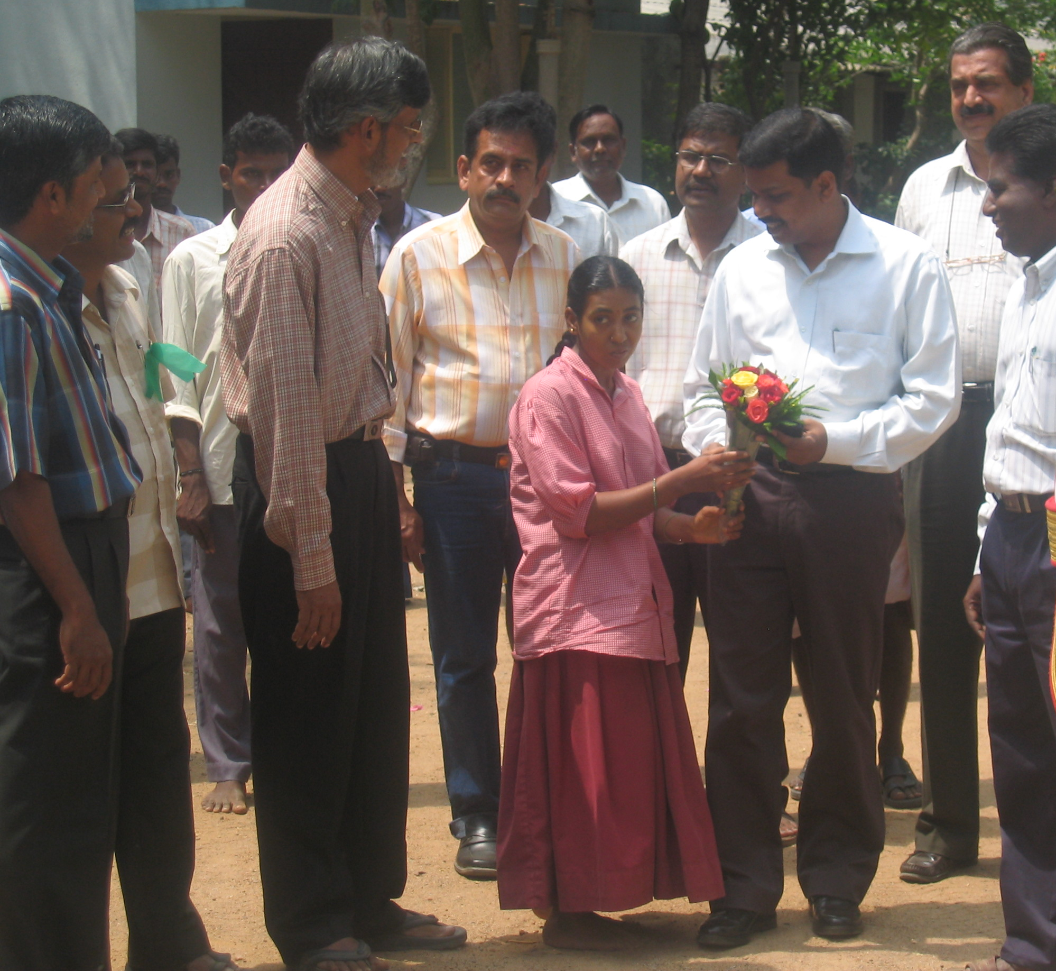
During the visit of the parents to center, more emphasis was given to the Parents to have vision for their children. It was also discussed and agreed with parents the children will get rehabilitation intervention from the center till the age of 18 years of the child and by that time they should plan and evolve a functional activity for the child so that an economic activity can be initiated for the child with the support of the parents at the Age of 18. Many parents started making a saving for the child every month to build a capital for this economic activity

Three days residential camp in March for the children with disability from the high school was an opportunity for the children to be together. They had lots of fun and recreational activities during the camp. Input was given on daily living skills.
Dt.Collector Shri.Satyabrata Sahoo, IAS at PCTC

A similar one day camp was organized for the primary school children with disability.

House adaptation was done for one child to start with, to make the living environment more suited the need and mobility of the child with disability. More children will be taken up during the coming years.

National Identity card camp was conducted at the center for the people with disability(PWD) with the support of the District administration. 400 People benefited from this camp.
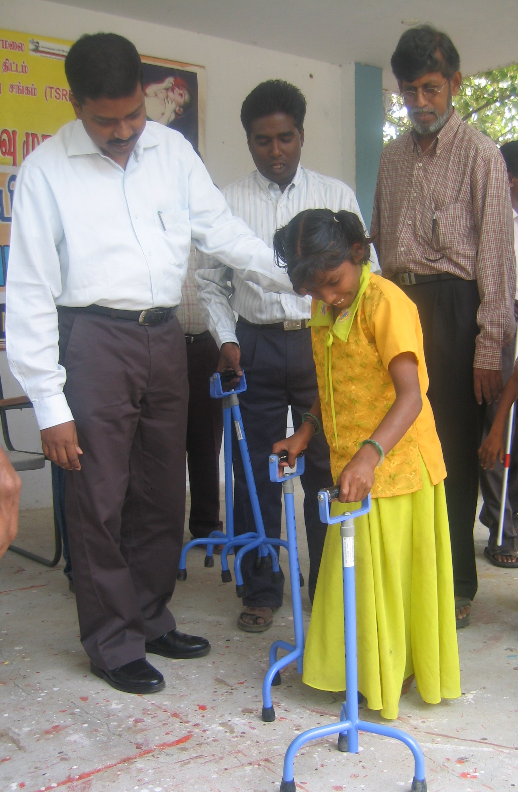
Rs;50,000 worth of Aids and appliances were given from Rehabilitation workshop for the children.

14 PWDs benefited from the Collectors discretionary fund as grant to the tune of Rs 9000 each for an economic activity identified by them.

As on date 50 Special self help groups exist for 288 PWDs. Among them 7 of them received revolving fund of 10000 and a bank loan of 30,000 each under the poverty alleviation program. 379 PWDs are integrated in the women groups.

249 School children received educational assistance from Government.

Our Day care center and the Early Intervention Room and Parent Training Room bears a new look due to the work of the English volunteers.

Thematically painted rooms is an attraction to the children with lots of new sensory and therapy aids and teaching materials.

Community Health Program

Through the community health program we had the usual activities like

- Working closely with junior Red Cross of Tiruvannamalai district in all theer training programs,
- Supply of Curry leaf powder for the Noon meal program in two blocks in Tiruvannamalai district
- Functioning as District Resource center for health promotion and Coordiantion of health activities for Tamilnadu voluntary health association
- Training of 25 Local first Aids (LFAs) for TNVHA –Tarangambadi Tsunami Intervention Program
- Conducting Health and herbal Exhibitions during Annual JRC camp in February, and on December 31st when PCTC had its community festival,
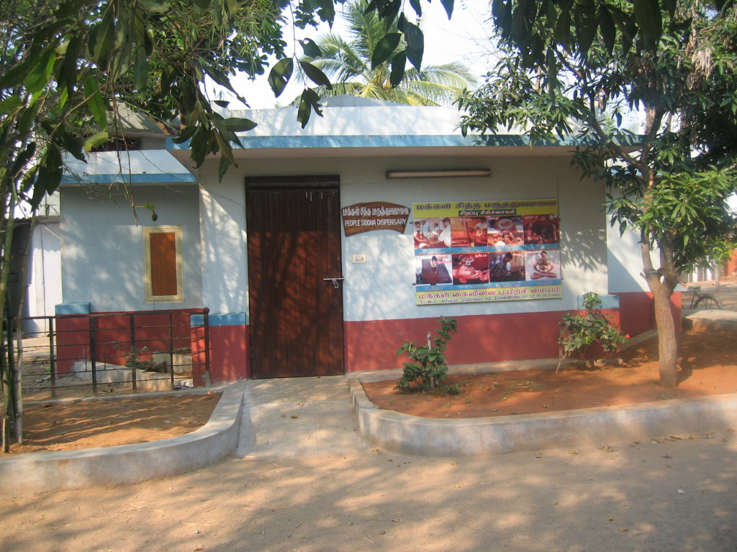
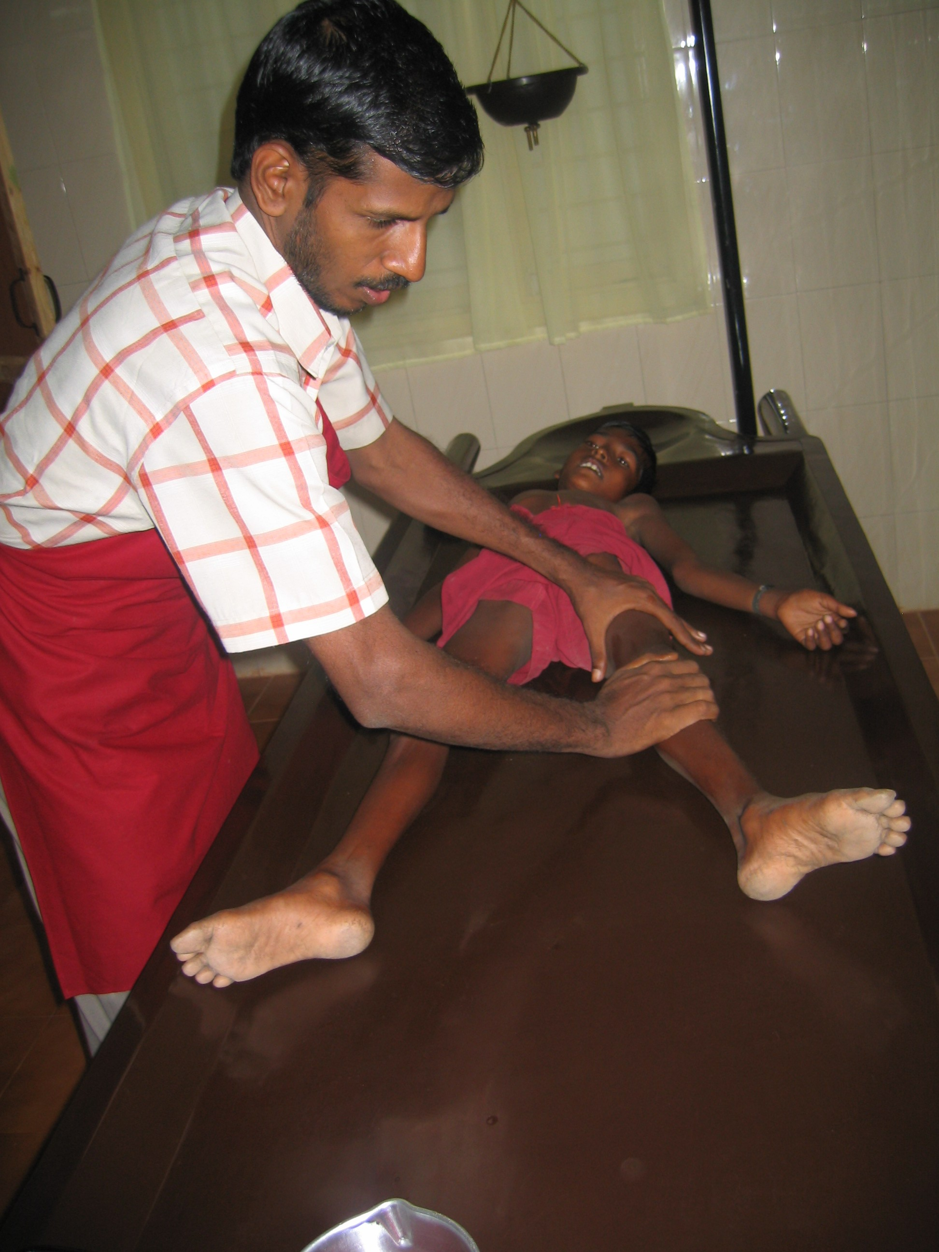
- Yoga Classes for Volunteers and Students,
- Regular treatment and follow up support services for people affected by HIV and Aids.
- Regular medical check up and treatment for sickness for the children with disability. 18 of the children had treatment for Epilepsy with a new regime of medicine.

As the old building of the Dispensary was damaged, A new building was put up with the support of Enfants du Monde France and Friends from Netherlands through Tess Verdonk. The New building Houses the massage unit, Steam bath unit as new additions.

Women Development Program:

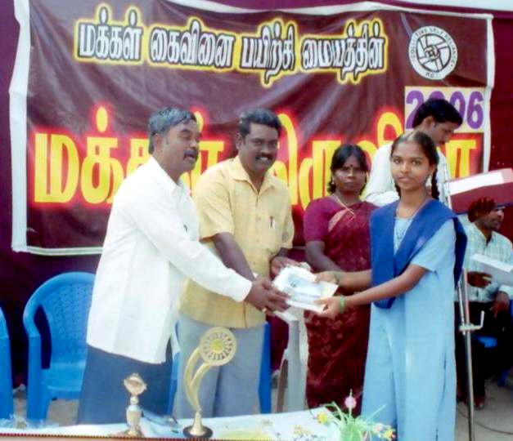
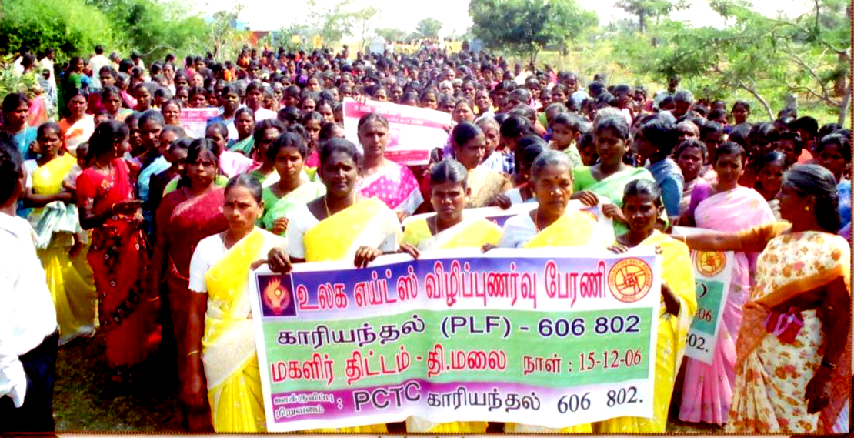
One of the main activity of the women development program is the Micro credit program. It has crossed 700 groups as on date. Most of the groups are economically viable. More and more groups getting Economic assistance from the Government is a welcome factor. We started realizing that the flow of money into the groups is also the beginning of problems in the groups if they do not adhere to the systems developed by us. During this year it was a realization that we need to educate members of the self help groups to adhere to the system. And also encourage the women to involve and actively participate in the community development activities.

We have initiated a process of strengthening the federation, by inviting the members to become life members of the federation, so that other welfare measures for the women can be organized. Around 1000 women have joined as life members.

In all the Panchayats Aids awareness program was organized. A total number 121 groups received Revolving Fund and 36 groups received economic assistance to the tune of 3.75 lacs each.

Skill training was given to 85 members in herbal cultivation, herbal medicine preparation

Conclusion:

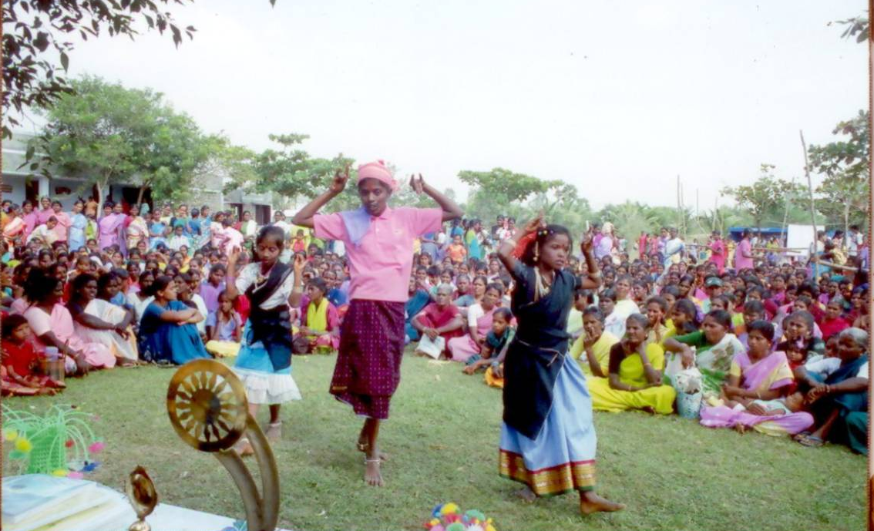
Every year that passes by is a good teacher, leaving behind lots of lessons that need to be put into practice. Good friends who spare time and energy with a will to bring in quality in the program, the committed team staff and Volunteer in the field and the extended fraternity of stake holders in the various programs makes it to happen the lasting impact seen in the community.

The continued support given by the Friends and Donors gives us the confidence to go further and further with an added vigor. It was a revelation for our team that the time has come to consolidate all our programs, so that our energy is focused and stays at the original objective of rehabilitation of people with Disability. All the other initiatives should support and complement this objective.

The District Administration and its various departments collaboration has helped us to canalize the various programs to people and the persons with disability.

